**CSCI 1411: Fundamentals of Computing**

**Lab 2**

**Due Date: February 02, 2022**

**Name: Abhinav Shrestha**

**Goals:**

* Use of simple input/output commands
* Use of simple operators +, -, /, *

**Development Environment:** IDLE**.**

**Deliverables:**

1. For the first part of the lab, you will create a screen shot of your output.
2. For the second part of the lab, you will create a screenshot of your output AND you will submit the Python file used to create Part II. Name the file using the following format:  
   YourlastnameFirstnameLab02.py.  
   Example: If your name is Joan Sanchez then you will name the file as follows:  
   SanchezJoanLab02.py

How to take a **screen shot**:

* For a Windows 10: Use Snipping Tool to copy and CTRL + V paste screen shot.
* For Mac: Shift + Command + 4 to copy and CTRL + V to paste screen shot.

**Part I – Skills Practice (10 points)**

* To install IDLE, click on <https://www.python.org/> or <https://www.python.org/downloads/> to download the desired released version of Python IDLE for your Windows, Linux, macOS, or others.
* Start Idle: In the computer lab you can use Cortana to search for IDLE app. Make sure that you use Python 3.x (where x can be 7, 8, 9, or 10). This will open IDLE window.[1]
* Click on FILE->New File on the top of the IDLE window (this may vary based on the operating system you use).

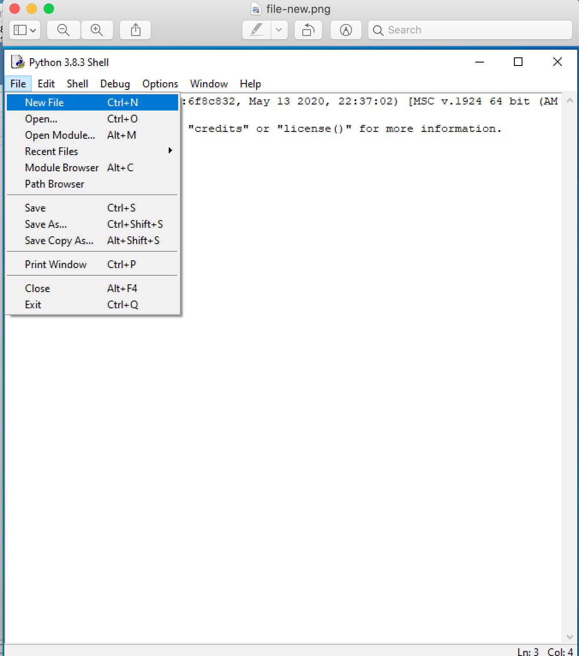

* A new window should pop up.
* In that new window, type in the code below…..**Do not cut and paste.** You will learn more by typing it in.
* Remember everything following a # is a comment.
* Remember that everything that is not a comment is case sensitive, meaning that upper and lower case matters!
* Change the comments to match your filename

# File YourlastnameFirstnameLab02a.py

# This is lab 2. It takes in a temperature in Fahrenheit and converts it

# to Celsius. It also queries the user for their name

def main():

# first, ask the user for their first and last names

firstName = input ("Enter your first name ")

lastName = input ("Enter your last name ")

# now ask them for the temperature they wish to convert

fahren = (int)(input ("What is the temperature in Fahreneit? "))

# next we convert using the standard F to C formula

celsius = (fahren-32)*(5/9)

# finally, print out the conversion

print (firstName, " ", lastName, " the Celsius temperature is ", Celsius, "degrees")

* Click on Run->Module. (You will be asked you to save the file. Name this file YourlastnameFirstnameLab02a.py )
* Running the module should take you back to the initial IDLE window.
* To run your program type in main()
* If there are any errors in your code, then you will get error message(s) as shown in the following screen shot:

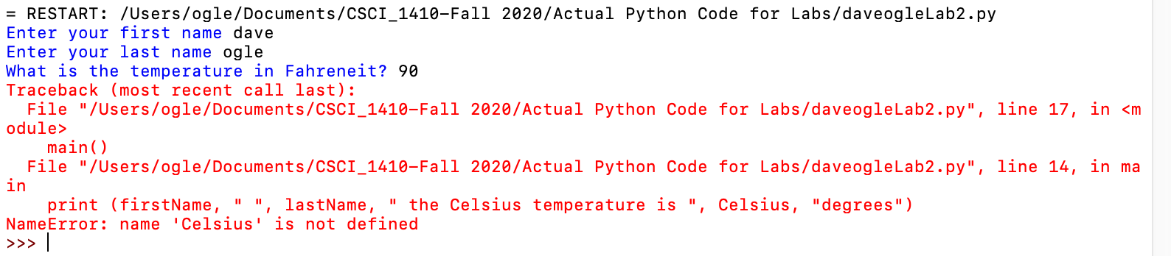

* In this error, you can see it is complaining about line 18. At line 18 in this example, the variable Celsius was used instead of celsius. Python is telling us that this variable is not known! When you get errors try to fix them. Sometimes the actual error is just above or below the stated line. Unless you have obvious issues, try to fix one thing at a time. Rerun your code after fixing each error.
* If you get dozens of errors, you may want to check the top few lines to make sure that they are written correctly.
* Once you get all the errors out, run your module/program again.
* Enter your First and Last Name when program prompt you for them
* Enter 90 when program prompt you for temperature.
* Program will display your name and temperature in degree Celsius.
* Now take a screen shot of the result.
  + Expand the run window by grabbing the edge and pulling up (until you see everything from the RESTART statement to the final >>> printed in the window. Use snipping tool to copy the screen shot and paste the screen shot below. You must include the screen shot to get credit for this part of the lab.
  + Insert that screenshot HERE

* Select File->Close to close your module.

**Part II – Converting a range of temperatures. (15 pts)**

* For Part II you are going to apply what you learned in Part I of this lab. Feel free to refer to Part I if you need help with starting a new project, naming your python file or running it.
* This part of the lab is similar to the first part, except instead of converting a single temperature, you will convert all the temperatures from the initial value entered to the initial value entered plus 10 degrees. For example, if the user enters 32 degrees, you will print out the conversion to celsius for 32, 33, 34, 35, 36, 37, 38, 39, 40, 41, and 42 degrees.
* These are the steps that you should take:
  + Create a new file
  + Ask for the user’s First Name and Last Name just like in the previous lab.
  + Ask for the initial temperature in Fahrenheit.
  + Print the user’s name followed by the conversion for each of the temperatures. HINT: you will have the same set of statements multiple times, just increasing the value of the temperature each time!
  + Sample I/O: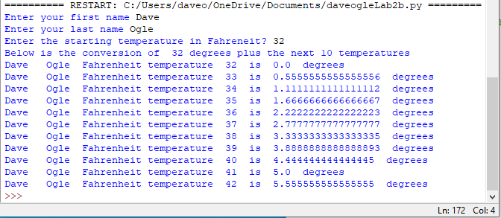

Every program should have the following comment block at the top. Make sure to fill in your name, lab partner’s name, class with section number, due date, brief description of your program, and status of your program:

*#*

*# Name:  
# Class: CSCI 1411-00X  
# Due Date:  
# Description:   
# Status:*

* Run the module. Save the file using the format YourlastnameFirstnameLab02.py . For example, SmithSallyLab02.py (if your name is Sally Smith)
* Correct any errors
* Run the module again
* Take a screen shot of the successful results and paste it below.

* Now you need to find the code to hand in. Click on File->SaveAs in IDLE. This will show you where the file is being saved. Remember the location and the filename.
* Upload this lab handout with required screen shots and your code file to Canvas to submit the lab.

1. Please see Installing Python page on Canvas.